**Supplemental content for “Power outages increase cardiovascular and respiratory hospitalizations among US older adults”**

**Supplementary Table 1**: Rate ratios and 95% confidence intervals for the association between county-level 8+ hour power outage exposure and CVD and respiratory hospitalizations in US 2018 Fee-For-Service Medicare beneficiaries for outages affecting ≥1%, ≥3%, and ≥5% of county electrical customers. Estimates are from conditional logistic regression models adjusted for wind speed, temperature, and precipitation. CVD is analyses of cardiovascular disease, Resp is respiratory disease.

|  |  |  |  |  |  |  |  |  |
| --- | --- | --- | --- | --- | --- | --- | --- | --- |
| Power outage cut point | Outcome type | Lag day 0 | Lag day 1 | Lag day 2 | Lag day 3 | Lag day 4 | Lag day 5 | Lag day 6 |
| 1% | CVD | 1.002,  [0.99, 1.014] | 1.020,  [1.013, 1.026] | 1.023,  [1.014, 1.032] | 1.006,  [0.999, 1.012] | 0.988,  [0.979, 0.997] | 0.991,  [0.985, 0.998] | 1.009,  [0.997, 1.021] |
| 3% | CVD | 1.015,  [0.999, 1.032] | 1.027,  [1.018, 1.036] | 1.027,  [1.014, 1.039] | 1.009,  [1.001, 1.018] | 0.993,  [0.981, 1.005] | 0.995,  [0.986, 1.003] | 1.008,  [0.992, 1.025] |
| 5% | CVD | 1.025,  [1.005, 1.045] | 1.031,  [1.021, 1.042] | 1.029,  [1.014, 1.044] | 1.014,  [1.004, 1.024] | 1.000,  [0.986, 1.014] | 1.000,  [0.99, 1.01] | 1.009,  [0.989, 1.028] |
| 1% | Resp | 1.026,  [1.012, 1.039] | 1.017,  [1.01, 1.024] | 1.009,  [1.002, 1.016] | 1.003,  [0.995, 1.011] | 1.000,  [0.993, 1.006] | 0.998,  [0.992, 1.005] | 0.997,  [0.985, 1.01] |
| 3% | Resp | 1.052,  [1.034, 1.071] | 1.031,  [1.022, 1.04] | 1.013,  [1.003, 1.022] | 1.001,  [0.989, 1.012] | 0.997,  [0.988, 1.006] | 0.998,  [0.99, 1.007] | 1.003,  [0.986, 1.02] |
| 5% | Resp | 1.067,  [1.045, 1.089] | 1.039,  [1.028, 1.05] | 1.016,  [1.005, 1.027] | 1.001,  [0.988, 1.015] | 0.997,  [0.986, 1.007] | 1.000,  [0.989, 1.01] | 1.007,  [0.986, 1.027] |

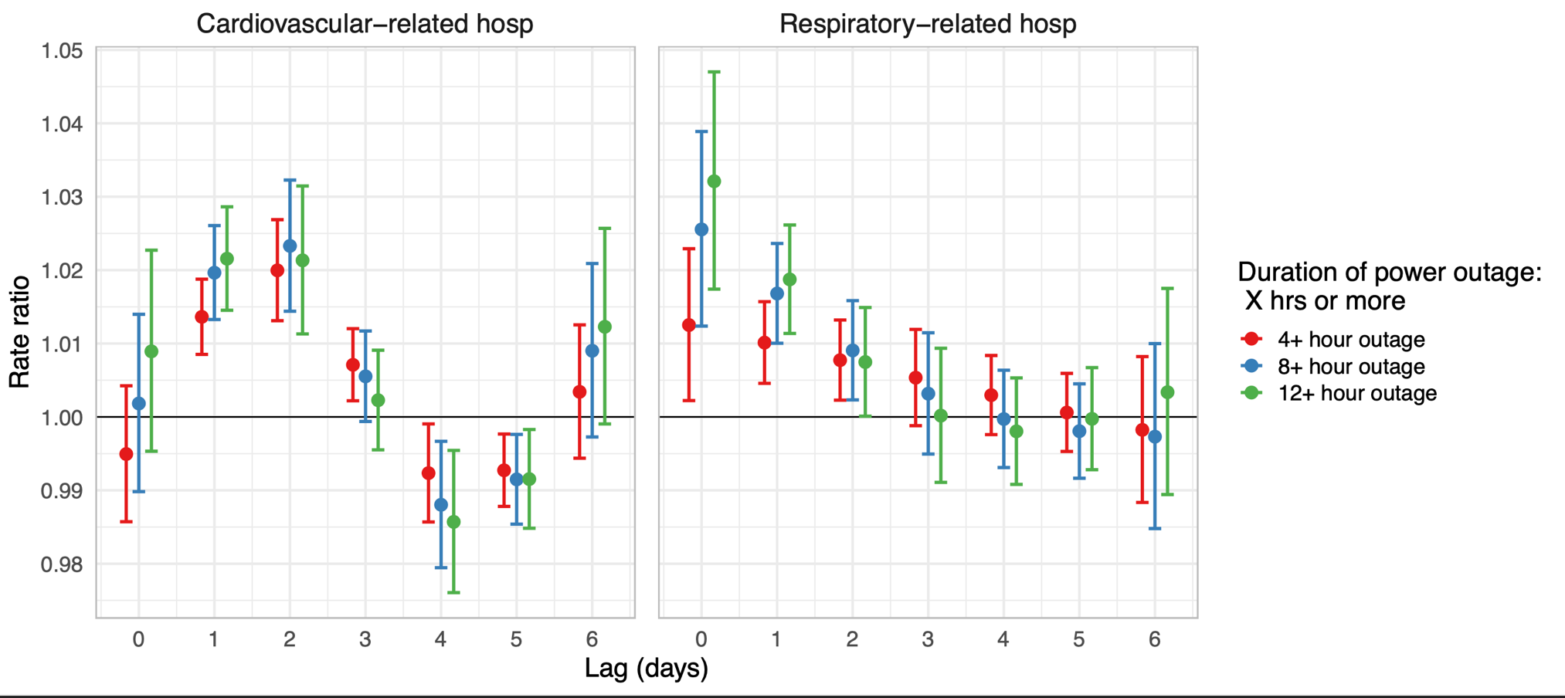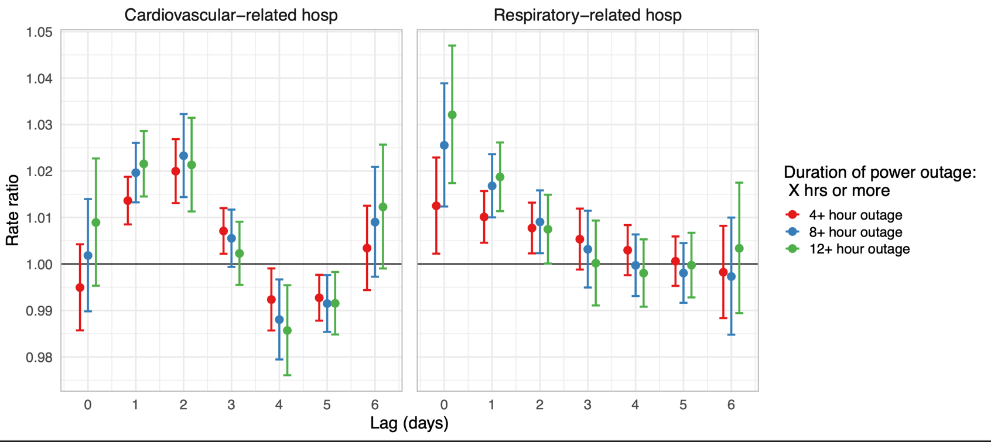**Supplementary Figure 1**: Rate ratios and 95% confidence intervals for the association between county-level 8+ hour power outage exposure and CVD and respiratory hospitalizations in US 2018 Fee-For-Service Medicare beneficiaries for 4+, 8+, and 12+ hour power outages affecting ≥1% of county customers. Estimates are from conditional logistic regression models adjusted for wind speed, temperature, and precipitation.

**Supplementary Figure 2**: Estimates and confidence intervals for the association between number of daily hours without power and CVD and respiratory hospitalizations in US 2018 fee-for-service Medicare beneficiaries.

CVD hospitalizations

Respiratory hospitalizations

|  |  |  |
| --- | --- | --- |
| **Proportion of county-days with 8+ hour power outage affecting ≥1% of county customers by potential confounder quartiles** | | |
| **Wind speed** | | |
|  | Quartile 1 | 0.009 |
|  | Quartile 2 | 0.009 |
|  | Quartile 3 | 0.010 |
|  | Quartile 4 | 0.022 |
| **Precipitation** | | |
|  | Quartile 1 | 0.013 |
|  | Quartile 2 | 0.014 |
|  | Quartile 3 | 0.012 |
|  | Quartile 4 | 0.011 |
| **Daily maximum temperature** | | |
|  | Quartile 1 | 0.022 |
|  | Quartile 2 | 0.012 |
|  | Quartile 3 | 0.009 |
|  | Quartile 4 | 0.008 |

**Supplementary Table 2**: Distribution of power outage exposure by potential confounders for main analysis of county-level 8+ hour power outage exposure and CVD and respiratory hospitalizations in US 2018 Fee-For-Service Medicare beneficiaries.